**Indian Institute of Technology Gandhinagar**



Product: Spotify

**MS 491 – I: Product Management**

End Semester Assignment

Instructor: Deepkumar Varma

~ Kevin Shah (20110096)

**Spotify: Changing the Tune of the Music Industry**

The digital revolution has led to significant changes in the music streaming industry during the past several years. People were using MP3, Napster, iPods, and even turning to illegal methods of downloading and listening to music for what seems like a lifetime ago. Prior to it, there were vinyl records, cassettes, and CDs. I couldn't imagine not having music at my fingertips—available whenever and wherever I want it—even though the concept of owning a record player at home and waiting in line outside the store to get the newest music drops looks endearing and fun! I could talk for hours about the history of music streaming, but for the purposes of this case study, I will be focusing on modern music streaming platform – Spotify!

1. **Product Overview**

*“Our mission is to unlock the potential of human creativity — by giving a million creative artists the opportunity to live off their art and billions of fans the opportunity to enjoy and be inspired by it.”  
 — Spotify Mission Statement*

**Problem Solving:**

Spotify addresses several key problems in the music consumption market:

1. Limited Access to Diverse Music:

Before the advent of streaming services such as Spotify, people's access to a wide variety of music was restricted. Acquiring individual songs or albums may be costly, so limiting the range of music that individuals could appreciate.

1. Inconvenience of Managing Music Collections:

It was inconvenient and labour-intensive to carry around physical music collections or manage digital downloads across many devices.

1. Difficulty in Discovering New Music:

It was difficult to find new music that fit one's tastes because conventional approaches did not provide personalized recommendations.

1. Limitations in Music Sharing and Collaboration:

Conventional approaches of creating playlists and sharing music with friends were constrained, either requiring manual sharing or the actual exchange of music.

1. Historical Issues of Piracy and Illegal Downloading:

The music industry faced serious issues from piracy and unlawful downloading, which had an impact on artists and rights holders.

**Market Positioning (SWOT Analysis):**

*“With more than* ***70******million*** *songs and endless hours of audio content, Spotify has emerged as the global favourite for music enthusiasts. By* ***2023****, Spotify will hold a* ***third*** *of the world's music streaming industry. Throughout the previous* ***five*** *years, Spotify's market share has consistently ranged between* ***32% to 43%****.”*A diagram of a diagram

1. **Product requirements (Next 3 months)**

**Step 1: Customer Profiling**

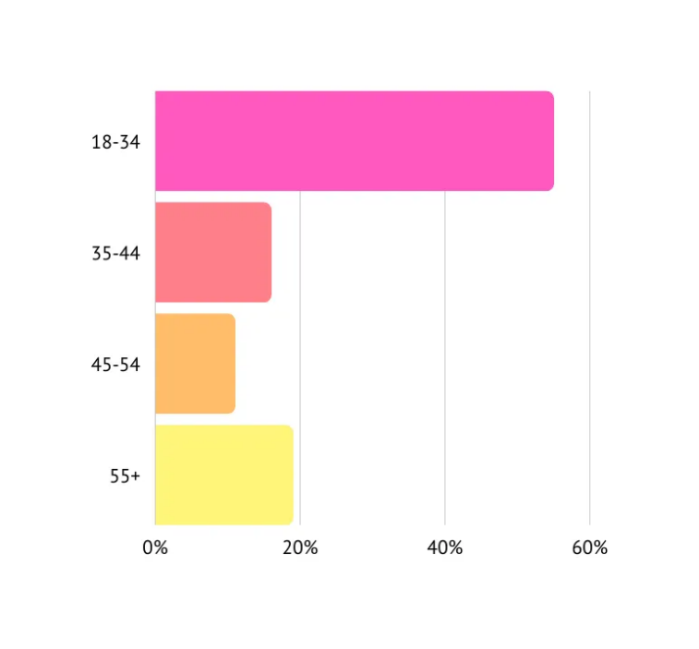

* Target Market: Individuals aged 18-34, emphasizing music enthusiasts and those seeking a personalized music experience.
* Demographics: Urban and suburban areas, with a focus on tech-savvy users possessing smartphones and internet access.
* Psychographics: Users valuing convenience, personalization, and the social aspects of music consumption.

**User Segments on Spotify:**

* Audience Size: Over 433 million active monthly listeners and 11 million artists/creators.
* Age Groups: Primarily Millennials and Gen Z, constituting 55% of users within the 18–34 age range.

**Focus:**

This case study centers on the massive audience of monthly listeners, specifically targeting **Millennials and Gen Z** listeners.

**Step 2: User Journey (***Spotify for Gen Z/Millennial Listener***)**

Users use Spotify for a variety of purposes and emotions throughout the day, and they are satisfied with the variety of content available. There is a need for improved social features, personalized identity expression, and direct engagement with favorite musicians while actively engaging with features like making playlists, following friends, and exploring recommendations. The lack of social engagement options on the platform occasionally causes irritation.

This user journey map highlights the user's changing demands, activities, and emotional states at each touchpoint of the day when they interact with Spotify. It offers perceptions into chances for upgrades and additions to raise the standard of the platform's general user experience.

**Pain Points:**

As a listener, a user navigates through these challenges:

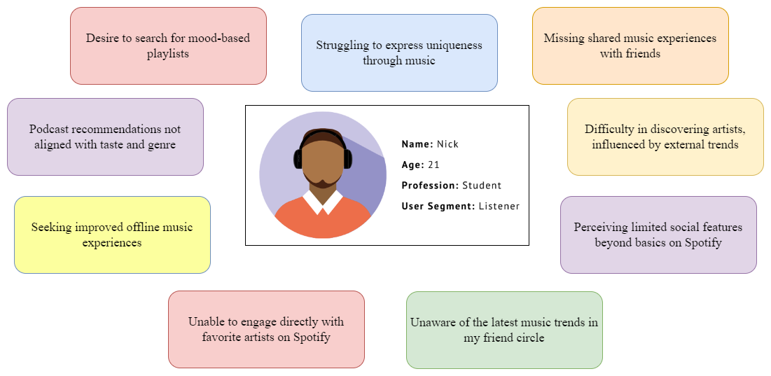

**Step 3: Identification of Pain Points and Solutions**

**Prioritizing Pain Points:**

|  |  |  |
| --- | --- | --- |
| **Pain Point** | **Pain scale** (☹️/5) | **Reasoning** |
| 1. Struggling to express uniqueness through music | ☹️☹️☹️☹️☹️ | Personalized identities are fundamental for user engagement, fostering a sense of individuality and self-expression. |
| 2. Missing shared music experiences with friends | ☹️☹️☹️☹️☹️ | Communal experiences enhance engagement, creating a social environment for users to share and discover music together. |
| 3. Difficulty in discovering artists | ☹️☹️☹️ | Current solutions may lack diversity, influencing user discovery. A more robust approach is necessary for a comprehensive artist exploration experience. |
| 4. Perceiving limited social features beyond basics | ☹️☹️☹️☹️☹️ | Expanding social features is critical to deepen user engagement, creating a more interactive and dynamic platform. |
| 5. Unaware of the latest music trends in my friend circle | ☹️☹️☹️ | Staying updated with trends is an outcome of deep engagement with social features, such as real-time feeds and shared activities among friends. |
| 6. Unable to engage directly with favorite artists | ☹️☹️ | Balancing artist engagement without transforming Spotify into a full-scale social media platform to avoid potential user dissatisfaction. |
| 7. Seeking improved offline music experiences | ☹️☹️☹️ | Enhanced offline capabilities are essential for a seamless and enjoyable user experience, especially in areas with limited connectivity. |
| 8. Podcast recommendations not aligned with taste and genre | ☹️☹️☹️☹️ | Personalized podcast recommendations based on user preferences are vital for a more enjoyable and relevant podcast discovery. |
| 9. Desire to search for mood-based playlists | ☹️☹️☹️☹️ | User-friendly search for mood-based playlists enhances emotional exploration, providing a more nuanced music discovery experience. |

Since the pain scale is high for pain points **1, 2, 4, 8, and 9**, here is the focused table tailored to specifically address the selected pain points, providing targeted solutions to enhance the user experience on Spotify.

|  |  |
| --- | --- |
| **Pain Point** | **Proposed Solution** |
| Struggling to express uniqueness through music | 1. Allow users to create customizable profiles showcasing musical preferences.  2. Implement a feature for users to share personal stories associated with specific songs. |
| Missing shared music experiences with friends | 1. Create public forums for music discussions and trending recommendations.  2. Implement collaborative playlists for real-time song sharing and commenting. |
| Perceiving limited social features beyond basics | 1. Introduce direct messaging and public commenting for user interactions.  2. Implement group features for users to form music communities and share recommendations. |
| Podcast recommendations not aligned with taste and genre. | 1. Personalize podcast suggestions using user feedback and analytics.  2. Implement an intuitive podcast recommendation algorithm considering both genre preferences and listening history. |
| Desire to search for mood-based playlists | 1. Allow users to specify mood and generate mood-based playlists accordingly.  2. Introduce a user-friendly search function for mood-based playlists. |

**Step 4: Business Analysis**

|  |  |  |  |  |  |
| --- | --- | --- | --- | --- | --- |
| Feature | Tech Feasibility | Cost Estimate | Customer Willingness to pay | Differentiation | Scale |
| Improved Customizable User Profile | High | Medium | High | **Yes** | **Yes** |
| Leveraging social media | Medium | Medium | Medium | **Yes** | **Yes** |
| Introducing Feed | High | Medium | High | **Yes** | **Yes** |
| Personalized Podcast Recommendations | Medium | Low | Medium | **Yes** | *No* |
| Mood-Based Playlist Search | Medium | Low | Medium | **Yes** | *No* |

* This table assesses each feature's technical feasibility, cost estimate, customer willingness to pay, differentiation factor, and scalability.
* The color-coding indicates the overall assessment of each factor.

**Step 5: Prioritization Model**

***RICE Method***

|  |  |  |  |  |  |
| --- | --- | --- | --- | --- | --- |
| **Feature** | **Reach** (Out of 5) | **Impact** (Out of 5) | **Confidence** (Out of 100) | **Effort**  (Out of 5) | **RICE Score** |
| Improved Customizable User Profile | 5 | 4 | 90 | 3 | 600 |
| Leveraging social media | 4 | 3 | 80 | 3 | 320 |
| Introducing Feed | 5 | 5 | 95 | 4 | 593 |
| Personalized Podcast Recommendations | 3 | 3 | 75 | 4 | 169 |
| Mood-Based Playlist Search | 3 | 3 | 70 | 4 | 157 |

**RICE Score Calculation:**

The RICE score is calculated using the formula:

$$RICE Score=\frac{Reach×Impact×Confidence}{Effort}. . . . . . . . . . . . . . . . . . . . . . . . . . . . . . . (1)$$

**RICE Score Interpretation:**

* Higher RICE scores indicate features with potentially higher impact and reach.
* "Introducing Feed" and “Improved Customizable User Profile” have relatively the highest RICE score, making it a priority due to its significant potential impact on user engagement and reach within the Spotify community.

1. **Features Design & Implementation (Solution)**

**Feature 1: Improved Customizable User Profile**

Here are some key elements that could be integrated into this enhanced profile feature:

1. Profile Customization:

* Users can personalize their Spotify profiles with avatars, banners, and bios, adding a playful touch similar to Snapchat's Bitmoji.
* Inspired by platforms like Medium, customization options extend to themes and colors, enhancing the visual appeal of the profile page.

2. User-Specific Details:

* Profiles display comprehensive user-specific details, including top artists and songs, now shareable with others.
* Information such as time spent listening, genre preferences, mood and energy levels, listening streaks, and a "Mood of the Week" offer a detailed overview of the user's music habits.

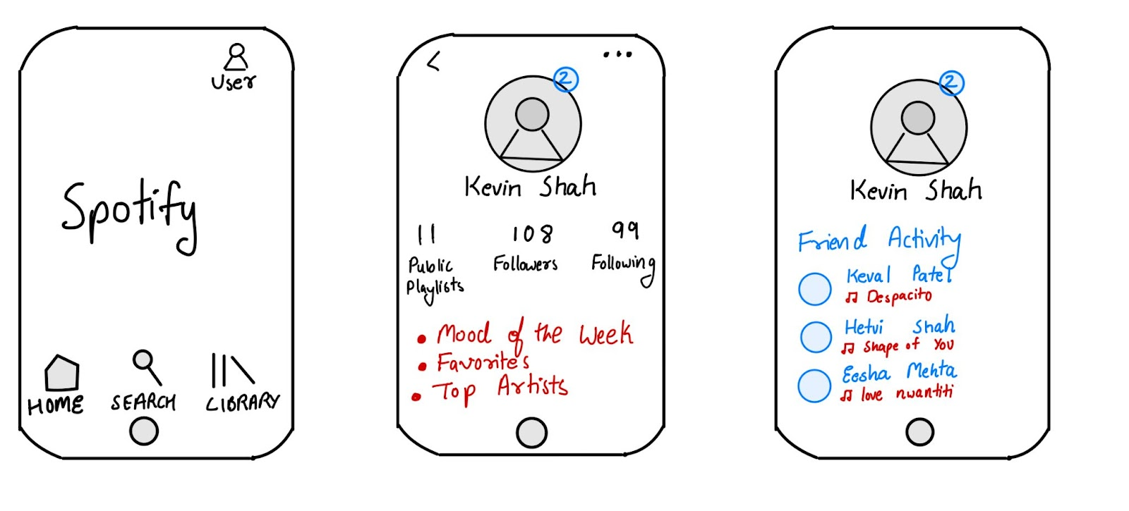

**Feature 2: Leveraging Social Media:**

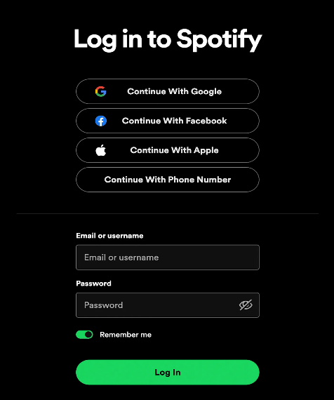

1. Private Accounts Feature:

* Allows users to control who sees their profile and approve followers.
* Provides privacy control, addressing issues of unwanted followers.
* Simplifies the concept to one unified "follower," similar to Instagram's model.

2. Better Social Integrations:

* Utilizes Facebook for follower recommendations, leveraging existing authentication.
* Personalized music recommendations based on friends' listening habits.
* Explores integration with platforms like Twitter and Instagram for diverse friend discovery.

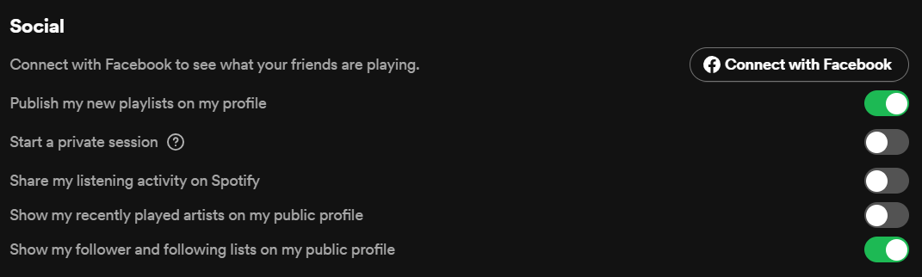

3. Seamless Music Sharing with Friends:

* Enables sharing music within the Spotify app.
* Followers receive automatic notifications for shared content.
* Streamlines the sharing process, eliminating the need to switch between different platforms.

**Feature 3: Introducing Feed:**

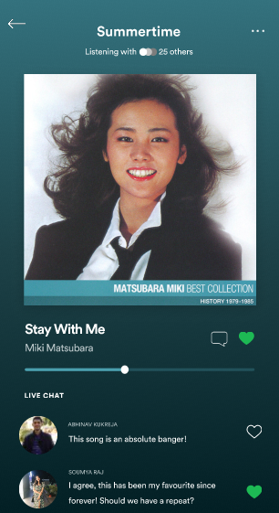

Through this navigation, a user goes through a process: Add Songs 🡪Invite People 🡪 Enjoy the feed with friends and interact with each other by also viewing other’s feed and songs.

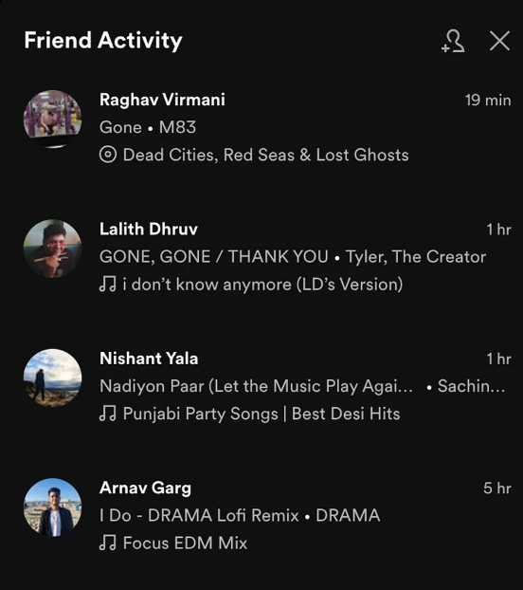

Overview:

The "Feed" feature in Spotify's main navigation menu introduces "Posts" and "Activity" tabs, enhancing the user's musical journey.

|  |  |
| --- | --- |
| **Posts** | **Activity** |
| Users express opinions on albums, songs, or playlists. | Track listening activity and playlist updates of others. |
| Followers react to posts and engage in discussions. | Discover weekly song trends within the user's network. |
| Fun polls for playful and interactive user engagement. | Receive personalized song recommendations based on network activity. |
| View trending posts from public accounts aligned with interests. | Option to go incognito for private listening activity. |

**Feature 4: Personalized Podcast Recommendations**

* 1. Algorithmic Personalization:
     + Utilize advanced algorithms incorporating user feedback and analytics.
     + Analyse user podcast preferences, listening habits, and feedback for personalized recommendations.

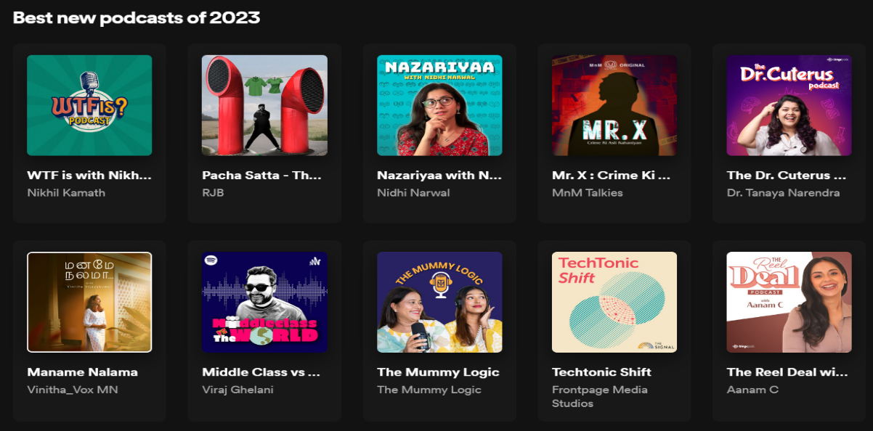

* 1. Genre Preference Integration:
     + Develop an intuitive recommendation system that considers individual genre preferences.
     + Implement algorithms to align podcast suggestions with users' specific genre interests.

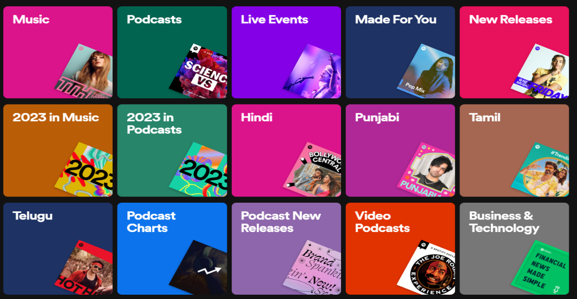

* 1. User Feedback Loop:
     + Introduce a feedback loop allowing users to rate and provide feedback on recommended podcasts.
     + Utilize user input to continuously refine and enhance the podcast recommendation algorithm.

**Feature 5:  Mood-Based Playlist Search**

* 1. Mood Specification:
     + Allow users to specify their current mood within the app.
     + Implement a user-friendly interface for selecting or describing their mood.
  2. Dynamic Playlist Generation:
     + Develop algorithms to generate mood-based playlists based on user-specified moods.
     + Incorporate a diverse range of music genres and podcast topics that align with the chosen mood.

* 1. Search Function Enhancement:
     + Introduce a dedicated search function specifically for mood-based playlists.
     + Enable users to explore and discover playlists curated to match their desired mood.
  2. Playlist Sharing and Collaboration:
     + Facilitate seamless sharing of mood-based playlists with friends and followers.
     + Introduce collaborative features, allowing users to contribute to and co-create mood-based playlists.



**4. Measure Success**

**A.**

|  |  |  |
| --- | --- | --- |
| **Customer Metrics** | Metric | Goal |
| User Adoption | Percentage increase in the number of users engaging with the new features | Achieve a 25% increase in user adoption within the first month. |
| Feature Retention | Percentage of users consistently using the new features after the initial adoption | Maintain a feature retention rate of at least 70% over three months. |
| User Engagement | Average time spent by users on the new features. | Increase average user engagement time by 20%. |
| Social Interaction Metrics | Number of social interactions within the new features (e.g., comments, likes, shares). | Achieve a 30% increase in social interactions. |
| Playlist Collaboration | Number of collaborative playlists created. | Encourage the creation of at least 15% more collaborative playlists. |

**B.**

|  |  |  |
| --- | --- | --- |
| **Financial Metrics** | Metric | Goal |
| Podcast Discovery | Increase in premium subscriptions attributed to enhanced podcast discovery. | Achieve a 10% increase in premium subscriptions directly linked to improved podcast discovery. |
| Mood-Based Playlist Search | Growth in advertising revenue from mood-based playlist search. | Increase advertising revenue by 8% through targeted promotions within mood-based searches. |
| User Engagement Impact on Revenue | Correlation between increased user engagement and revenue growth. | Demonstrate a positive correlation between the rise in user engagement and a corresponding increase in revenue. |
| Feature Contribution to Average Revenue per User (ARPU) | Average revenue generated per user directly attributable to the new features. | Achieve a 5% increase in ARPU linked to feature adoption. |

**C.**

|  |  |  |
| --- | --- | --- |
| **Learning & Growth** | Metric | Goal |
| Tech Performance | System stability and error rates during feature usage | Maintain a system stability rate of 99.5%. |
| Learning & Development Participation | Percentage of team participation in knowledge-sharing sessions. | Achieve 100% team participation in at least two knowledge-sharing sessions. |

**D.**

|  |  |  |
| --- | --- | --- |
| **Internal Business Procedures** | Metric | Goal |
| Innovation Index | Number of innovative ideas generated by the team. | At least one new innovative idea generated within the quarter. |
| Feature Release Efficiency | Time taken from feature development to release. | Reduce feature release time by 15%. |
| Bug Resolution Time | Average time taken to resolve reported bugs. | Maintain an average bug resolution time of 48 hours. |

References:

* <https://www.demandsage.com/spotify-stats/>
* <https://newsroom.spotify.com/2023-03-08/spotify-previews-clips-music-podcasts-audiobooks-home-feed/>
* <https://techcrunch.com/2023/01/31/spotifys-test-of-a-friends-tab-on-mobile-hints-at-expanded-social-ambitions/>
* <https://techcrunch.com/2022/06/22/spotify-is-developing-community-a-new-place-to-see-your-friends-activity-in-the-mobile-app/>
* <https://www.demandsage.com/spotify-stats/>
* Interface Figures: My Own Spotify.com Interface
* Visual Charts and Tables formed on draw.io

------------------------------------------------------- THANK YOU --------------------------------------------------------